Name: B. Krishna
ID: 2400030120
Sec: 09
Exp: 2
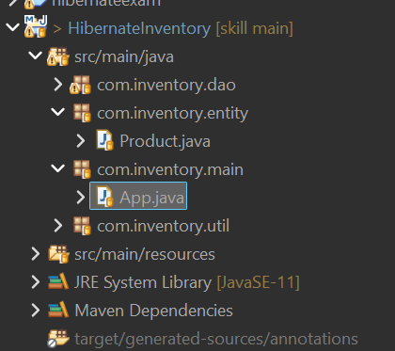

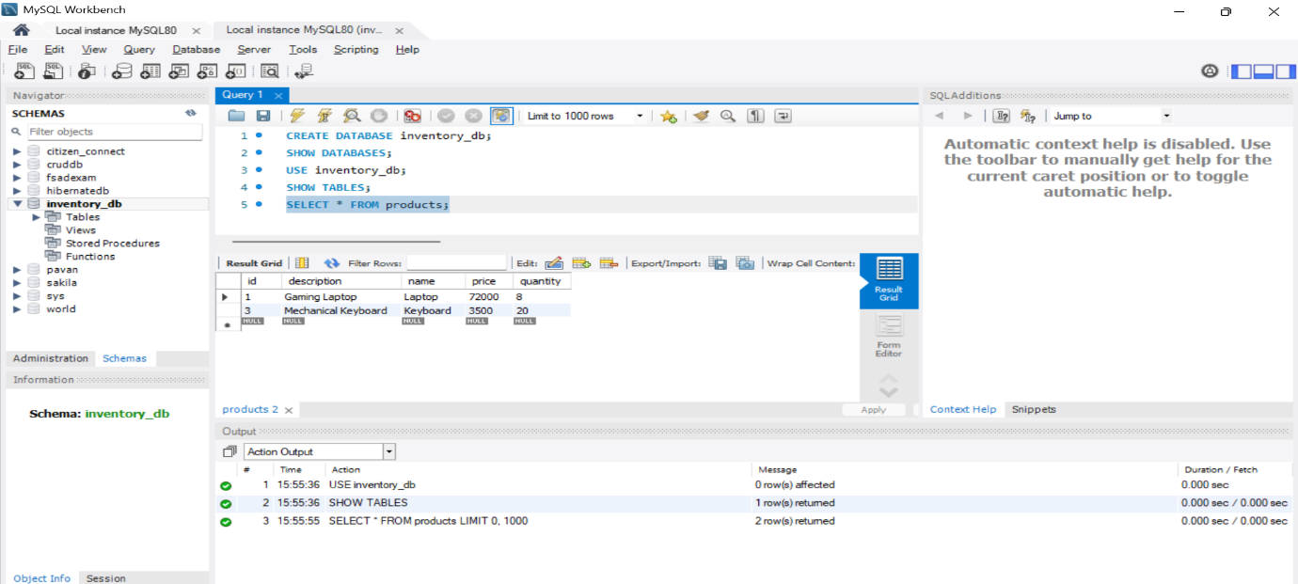
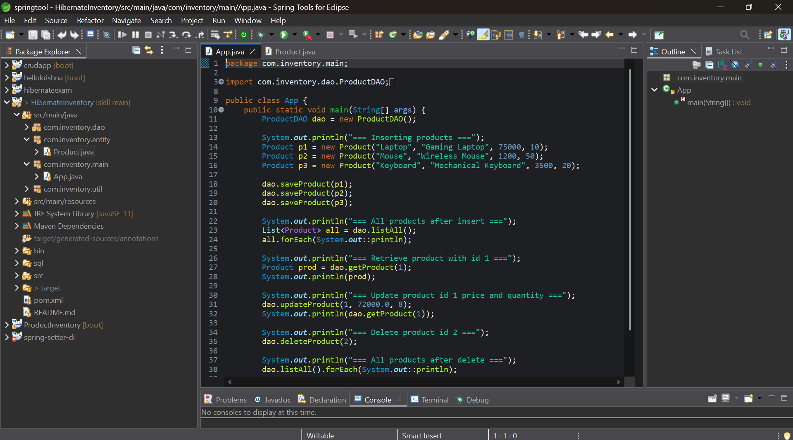https://github.com/krishna3324/Fsad-Skill.git

